Ecology of Populations
What is ecology? ___________________________________________________________.

Population Growth - Populations grow when ___________________
rate exceeds rate of mortality ________________.

Age Distribution - Age-Structure Diagram shows growth
patterns of populations grouped into
categories
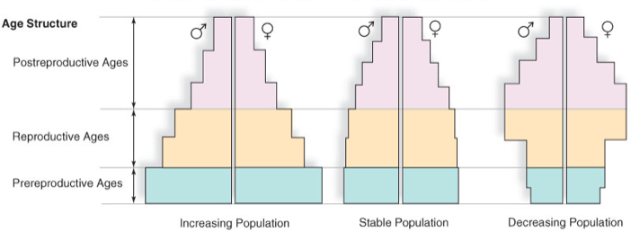

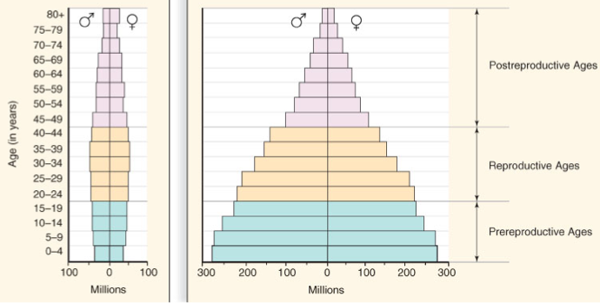

_________________ _____________________

What is the difference in population density between developed and less-developed countries?
____________________________________________________________

___________________________________________________________.

Humans are part of the Earth's __________________. Human activities can either _______________________ or _____________________ alter the balance of an ecosystem.

How do human activities affect the environment?
___________________________________________________________

___________________________________________________________.
Human impacts on the Environment:

Global warming
Use of machinery by humans ________________ to be increasing _________ levels in the air. CO2 prevents heat from escaping, possibly causing slight ___________________________ temperature increases.

Deforestation
• Caused by demand for ____________ products, need for ____________, farmland, housing, and roads.
• ________________________ causes habitat _______________________. Animals and _______________ are forced into confined areas.

Ozone depletion
• Caused by aerosol chemicals called ___________________________ (CFCs).
• CFC’s
– Escape into _______________________, reacts breaking down the ozone (______, a protective atmospheric layer).
– _______ rays penetrate the atmosphere and cause _______________ to many organisms.

Fishing activities
• Demand for fish and ________________.
• Commercial Fishing can be ____________________ to environment in many ways.

Invasive species (EXOTIC SPECIES)
• Introduced by people _________________________ or intentionally.
• Can cause problems if no ____________________ enemies are present.

Do you know of any invasive species?
1.
2.
3.
4.
5.

Exotic pet trade
•__________________ and sell wild animals from exotic locations.
• Wealthy buyers and collectors desire ____________________ animals
• Animals removed from their ___________________ causes an _________________________________ in the ecosystem.

Importance of the Environment:

Biodiversity - Many different types of ________________________.
• Organisms depend upon ____________ another.
• Interfering with one organism can have a ____________________ effect to many within the ___________________.

Natural resources
___________-renewable includes fossil fuels (petroleum, coal).
________________________ includes animals, plants, water, wind, etc.
–even renewable ____________________ can run out.
Renewable energy sources include _______________________, geothermal energy, _________________ currents.

Agricultural
–DDT
–Fertilizers
–Animal _______________ (nitrogen)
Homes
–Strong ________________ agents
Industry
–___________ gases and wastes
–______________ rain

Sum it Up!
What are three new things you learned about Ecology?
1.

2.

3.

Has your opinion changed about the environment? Explain.

What can you do to help the environment? Explain.

