Predicting Weather
Cold Front
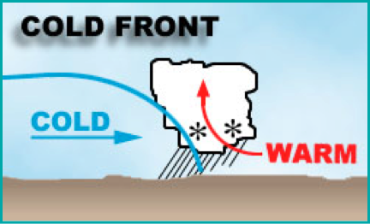
In the ____, most Cold Fronts travel in a ______________ direction across the country.
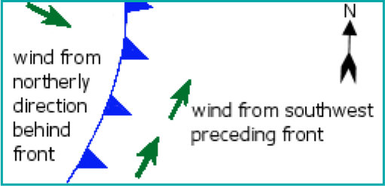
As a _________ _________ passes, the wind will normally shift from a ___________ to a ___________ direction.

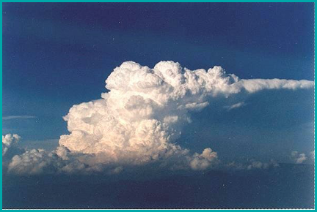
Another indicator of an approaching ______________ is the presence of ___________________ ___________.

Colder weather occurs after a ___________ __________ has passed.

Warm Front
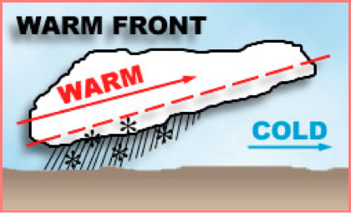
In the US, most __________ _________ travel in a _________________ direction across the country.
When a _________ _________ passes, the wind will normally shift from an ________________ to ___________________ direction.

Another indicator of an approaching _________ _________ is the presence of _________________ ___________.

Warmer weather occurs after a _________ _________ has passed.

High Pressure
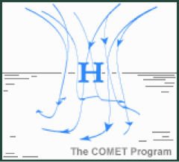
A ________ ___________ system is an area that has diverging, sinking winds and a ____________ rotation.
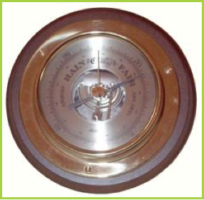
Rising pressure indicates ___________ ____________ is approaching.

Low Pressure
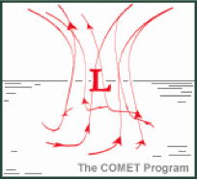
A _________ _________________ system is an area that has converging, rising winds and a ________________________ rotation.

___________ _____________ is often associated with low pressure systems.
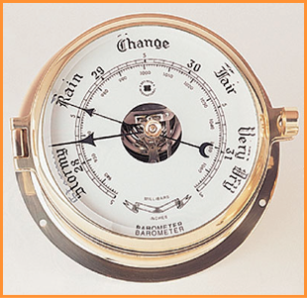
Sinking pressure indicates ___________ _________________ is approaching.

